A wonderful new limited edition
from KEN PIESSE FOOTBALL & CRICKET BOOKS
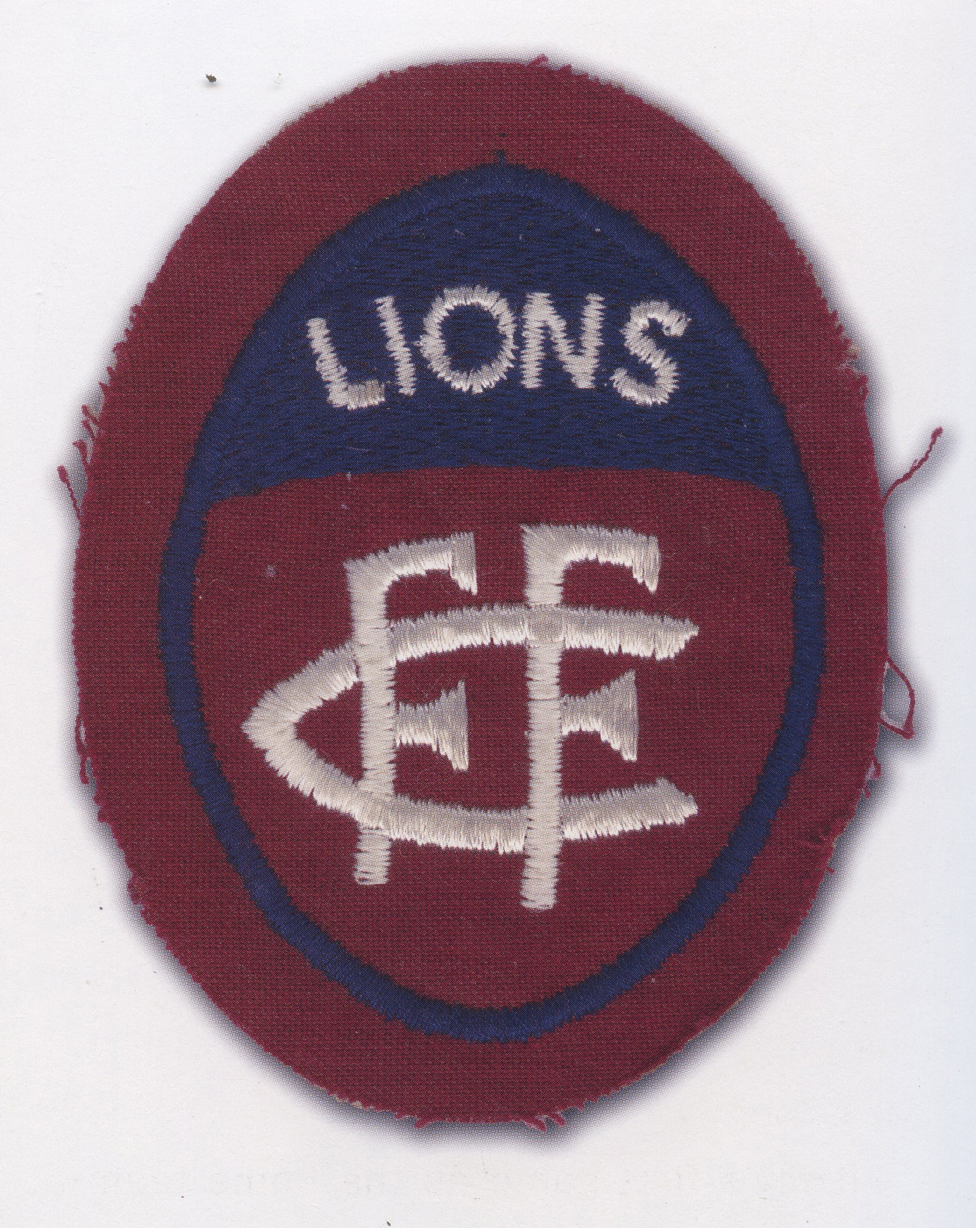
MIRACLE MATCH
The day David downed Goliath, Brunswick St., July 6, 1963
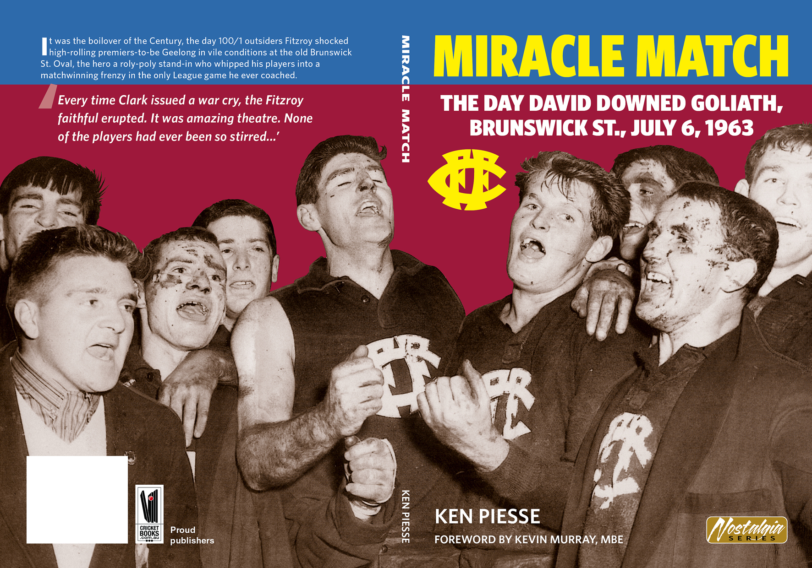It was the Boilover of the Century, the day 100/1 outsiders Fitzroy shocked high-rolling premiers-to-be Geelong in vile conditions at the old Brunswick St. Oval, the hero a roly-poly stand-in who whipped his players into a matchwinning frenzy in the only VFL game he coached.
Miracle Match is being published in July in a limited edition of just 563, of which the first 63 have been signed by Fitzroy’s greatest living player Kevin Murray, MBE…. These is sure to sell out fast! Ensure your copy of MIRACLE MATCH now!
DELUXE HARDBACK EDITION (of 63) $60
STANDARD LIMP EDITION $30, sent POST FREE

Yes! Please send me the standard edition/ signed by Kevin Murray limited edition of Miracle Match. I enclose a cheque/postal order for $30/$60…. or will pay EFT

NAME……………………………………………………………………………….

ADDRESS………………………………………………………………………………

…………………………………………… POSTCODE…………………………..

EMAIL……………………………………………… Phone……………………….

SEND TO: KEN PIESSE FOOTBALL & CRICKET BOOKS,
PO BOX 868 MT ELIZA 3930 VICTORIA….
EMAIL: kenpiesse@ozemail.com.au
PHONE: 0419 549458
WEB: www.cricketbooks.com.au

‘Every time Wally Clark issued a war cry, the Fitzroy faithful erupted. It was amazing theatre. None of the players had ever been so stirred...’
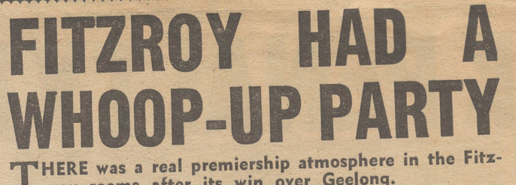

Foreword by
KEVIN MURRAY
Friday night, July 5, 1963. It was 6 pm and already pitch black. The temperature had tumbled into single digits and a scotch mist illuminated the lights of the City. Wally Clark had called all the Fitzroy players to the Brunswick St. Oval for a Council of War. The bottom-of-the-ladder Lions, without a win all year, were opposing glamor team Geelong, a prime premiership fancy. It was a Mission Impossible… or was it?
